Nonlinear Dynamics, Psychology, and Life Sciences, Vol. 13, No. 0, pp. xxx-xxx.
© 2009 Society for Chaos Theory in Psychology & Life Sciences

Nonlinear Dynamics, Psychology, & Life Sciences: Instructions for Authors and Manuscript Template

Your Name, Organizational Affiliation
Your co-author, Organizational Affiliation

Abstract: This is the format for a journal manuscript. APA style is used for all preparation points except the style of headings and subheadings, the use of abbreviations for “Figure” (Fig.) and “Equation” (Eq.), and a few points that are germane to this journal that are not explicitly covered by the APA style guide. There is another file on the NDPLS web site that can be used as a WORD template or simply as a reference guide. This version is intended to show authors how a manuscript will be transformed into print format. Instructions for composing the abstract itself appear in this document under the heading for abstracts. The 2009 revisions are intended to clarify points that are frequently missed by authors and to amplify technical points that were not covered in the 2003 version but have evolved since that time. The most extensive additions pertain to the composition of equation boxes and figures.

Key Words: [Please supply up to five keywords for indexing. See additional instructions below.]
JOURNAL PURVIEW
Nonlinear Dynamics, Psychology, and Life Sciences publishes papers that augment the fundamental ways we understand, describe, model and predict nonlinear phenomena in psychology and the life and social sciences. One or more of the following nonlinear concepts must be an explicit part of the exposition: attractors, bifurcations, chaos, fractals, solitons, catastrophes, self-organizing processes, cellular automata, genetic algorithms and related evolutionary processes, and neural networks. The broad mixture of the disciplines represented here indicates that many bodies of knowledge share common principles. By juxtaposing developments in different fields within the life and social sciences, the scientific communities may obtain fresh perspectives on those common principles and their implications.
Because the journal is multidisciplinary in scope, articles should make an original contribution to at least one substantive area and should in addition illuminate issues beyond that area's boundaries. Papers, however excellent, which pertain only to an overly narrow field of interest, are not appropriate for this journal. The problem statement and literature background should be composed with the interdisciplinary nature of the readership in mind. Although it is possible to assume our readers’ general familiarity with the nonlinear constructs, they are probably more variable on the background of specific application topics.
All manuscripts must be submitted in English and must meet common standards of usage and grammar. In addition, because this is an interdisciplinary journal, the introduction, at the very least, must be readable to a broad range of life and social scientists. Arcane jargon should be avoided. The scientific importance of the paper and its conclusions should be made clear in the introduction. The introduction should contain a description of the problem under study, its historical background, its relevance to psychology, life or social science, the specific phenomena which can be described or investigated, and the outstanding open issues.
Articles must make original contributions to the understanding of dynamical processes as defined above, and the exposition must be rigorous. Papers can focus upon theory, experimentation, algorithms, numerical simulation, and applications to problems in any of the foregoing substantive areas. Overly abstract papers, however, in which the application to psychology or to life or social science issues is not apparent are not appropriate for this journal.
There are five types of articles that may be submitted:
1. Regular articles report original theory or empirical research containing on the order of 3,000 – 10,000 words.
2. Research reports are short communications detailing original research results, typically under 3,000 words.
3. Theoretical contributions are succinct communications detailing original insights of a theoretical nature, typically fewer than 4,000 words.
4. Review articles are major overviews of domains of inquiry relevant to the study of nonlinear phenomena in psychology, life or social sciences, typically over 10,000 words. The Editor may solicit these although proposal are welcomed and should be discussed directly with the Editor.
5. Book (and software) reviews are summaries of content with critical observations of books on some aspect of nonlinear theory, analysis, or application to problems encountered in psychology, life and social sciences. Software reviews summarize of the scope and features with critical observations of software that is of interest to those who research topics in nonlinear dynamics. Book and software choices should be discussed in advance with the Editor. Reviews should be no longer than 2,000 words.
Topics in philosophy of science can be considered if the subject matter can explicitly promote advancements in research and theory in nonlinear dynamical systems. Papers use developments in nonlinear dynamical systems to enlighten answers to philosophical problems or questions should be sent to journals that specialize in those subjects.
Articles involving experimentation, numerical simulations, or real-world application should be constructed in the standard four-part format: an introduction containing the problem statement and relevant literature background, method, results, and discussion remarks on the theoretical explanations for the experimental results. The METHOD section should be formatted in APA style, with the following parts in order: Description of participants or other data source, procedures of the experiment, measurements taken and used in the analyses, and an overview of the analytic procedures that were used.
MANUSCRIPT SUBMISSION AND REVIEW

Initial Submission
Manuscripts may be submitted in hard copy or electronically. For hard copy submission, four copies of the manuscript should be sent to the Editorial office: Stephen J. Guastello, Ph.D., Editor, Nonlinear Dynamics, Psychology, and Life Sciences, Dept. Psychology, Marquette University, P.O. Box 1881, Milwaukee, WI 53201-1881.
Electronic submissions may be sent to the Editor: stephen.guastello@marquette.edu. The subject heading of the e-mail message and covering e-mail should state clearly that the manuscript is being submitted for review and possible publication in NDPLS. NDPLS follows the standard protocol of only considering manuscripts that have not been published before and are not under consideration by any other journal. Manuscripts that are submitted electronically must be in WORD or PDF format. WORD documents must be prepared in the 2003-06 version. We are not accepting the 2007 version for the Vista operating system at this time; files made on the Vista system (files with extensions ending in .docx) can be saved in the earlier version, however.
There is a limit on the file size for electronic submissions. Please keep the file size less than 2MB. If the file is larger, please remove the figures and send those in separate e-mail that are no larger than 2MB. Please see below for acceptable formats for figures.
Please include a cover letter designating the author to whom correspondence should be sent and providing that author's current postal address, telephone and fax numbers, and e-mail address. Postal addresses from universities and other organizations should include the author’s name, department of operation, name of the institution, street address or post office box, city, state (province or equivalent), zip or postal code, and country (if not USA). This correspondence address should appear on the title page of the manuscript as well; please see below.
In addition the author may specify in the cover letter or covering e-mail a member of the editorial board to whom the paper could be directed for technical peer review. The names of the Editorial Board members and their areas of interest are listed on the inside of the front cover of the journal and on the journal’s website. Specification of an Editorial Board member is not required, however.

Review Procedures
All papers will undergo a two-part review process unless the Editor notes at once that the subject matter of the paper is not suitable for the journal; in this case it will be returned promptly to the author. Manuscripts that are considered suitable for review will be sent to the member of the editorial board chosen by the author, and other reviewers at the discretion of the Editor. Board members will then arrange for additional peer review of the technical content of the paper or write the reviews themselves. Reviewers will be selected to advise on the technical content of the paper as well as its accessibility and applicability to a sufficiently broad audience within the psychology, life and social science community. Every effort will be made to secure a decision about the paper within two months and to publish final versions of articles as quickly as possible.
Revisions may be required at the Editor’s discretion. If the revision request is relatively light, the decision regarding final acceptance can be made promptly by the Editor. If the revisions are more extensive, however, the reviewers who requested the revisions will be asked to review the paper a second time. In either case, authors should include a cover letter with their revised paper describing the changes that were made.

Final Manuscripts
The review process concludes with a contract to publish the article in NDPLS. Authors are required to return the original signed copy to the Editorial Office along with any outstanding material requested by the Editor. The contract requires the authors to give assurance that the work is their own and that all permissions have been obtained from the appropriate copyright owners for material that originally belonged to other authors. The contract transfers copyright ownership of the work from the author to the publisher (The Society for Chaos Theory in Psychology & Life Sciences). Authors will retain the right to reuse parts of their work in new forms under most types of conditions. Please refer to the Permissions page on the NDPLS web site for further details on allowable materials and conditions.
The final versions of accepted manuscript must be prepared in WORD 2003-06 series format. LaTex documents are not acceptable; authors using LaTex are asked to transform their files into WORD. The final manuscript and figures may be submitted by e-mail, with the same limits on file sizes mentioned above in conjunction with initial submissions. Alternatively,
a disk (Zip, or CD) containing the final manuscript and figures may be mailed to the Editor. Figures should be included as separate files in BMP, JPG, TIFF, or GIF formats. Alternative graphics formats may be used by prior arrangement with the Editor.
Page Proofs
Page proofs are sent in PDF format to the corresponding author at the e-mail address given on the title page of the manuscript. Please compare the proofs against your original document and check the typography. Please note that minor copy-edits may have been introduced by the editorial staff, although any items that were thought to be of substantive importance are specifically cleared with the author either prior to the delivery of the proofs or brought to the author’s attention when the proofs are delivered.
Corrections at this stage of the process must be limited to items of accuracy. Substantive or stylistic revisions cannot be incorporated at this time. Proof corrections should be returned to the Editor or other journal staff person who sent the proofs by e-mail whenever possible. Proof versions of NDPLS manuscripts are line-numbered to facilitate corrections. To return proof corrections by fax or air mail, please see the file “Instructions for Page Proofs” that appears on the NDPLS web site under the menu heading for Instructions.
Be sure to check figures, their numbers and captions, table alignments and titles for proper placement and agreement. Proof figures may or may nor show the same level of resolution as the printed final version. Technical proofs of figures are done by journal staff who will advise authors when a problem arises, although this particular aspect of production is usually done around the time the final manuscript is received from the author.
We typically allow five to seven calendar days for the return of the proofs. The particular deadline will be specified at the time the proofs are sent. In the event the corresponding author is unavailable to check the proofs, the author may delegate the task to another author or to another individual on their behalf. If we do not receive a reply by the specified deadline, however, we will either move ahead with publication without the proof corrections from the author or delay publication until a later issue at our discretion.

MANUSCRIPT PREPARATION
Standard manuscript format is requested: double spaced type, one inch (2.5 cm) margins, on 8.5 x 11 (inch) paper (or A4 size). Do not justify the right margin in your manuscript. Paragraphs should begin with an indentation of approximately 0.5-inch (1 cm).
Use Roman type throughout the text with the exception of the mathematical characters or characters required from a multinational font. Mathematical characters should be written directly from the Symbol font as needed. The “insert character” facility of WORD should not be used for manuscripts that are sent by e-mail. See below for additional details pertaining to the preparation of mathematical notation.
The type size should be 11-point or 12-point, except in equation boxes where the type size is 10-point. Additional instructions appear below concerning the construction and use of equation boxes.
Do not syllabicate words at the end of a line of type. If the complete word cannot fit on a line, let it start on the subsequent line. The final page layout for an article will inevitably require syllabication at locations that are different from apparent locations in the manuscript.
Hyphenated words are hyphenated according to standard spelling conventions in English. The word “nonlinear” is never hyphenated in NDPLS, however.

Title page
The title should be brief, descriptive and appropriate for indexing. Each author's name and affiliation should be listed. Also include the corresponding author’s contact information. Provide an abbreviated title using no more than 50 characters for use as a running head. See the examples of front-page information shown on this file. Insert a page break before the start of the abstract.

Abstract
The abstract should be no more than 200 words. It should provide a summary of the problem statement, how it was studied, the main results, and the conclusions. Abbreviations or mathematical formulas should not be used in an abstract. Citations should be avoided in an abstract, but when there are absolutely necessary they should be written out in full. The abstract should be constructed in one paragraph. There should be a page break after the correspondence information above and after the keywords below.

Key Words
Please provide a list of up to five keywords describing the subject areas of the paper. Key words should appear just below the abstract on the abstract page. It is recommended that the key words should be those that do not appear in the title. A key word index for NDPLS appears on the NDPLS web site (www.societyforchaostheory.org/ndpls) under the menu option “Indexes.” Use of these terms is recommended where applicable but not required. For authors who are accustomed to JEL numerical index terms, please translate the numbers into recognizable words. Insert a page break after the keywords and before the start of the body of the text.

Abbreviations
Define abbreviations when they first occur in the text and thereafter use only the abbreviations. Consider the possibility that too many abbreviated terms will produce an incomprehensible manuscript except to those readers who are the most familiar with the subject matter. When in doubt on this point, use full words.

Headings and Subheadings
The convention is to center first-order subheadings, upper case lettering, on the line on which they are to appear using the standard 11- or 12-point type throughout. Headings should be set in boldface type. Second-order headings are centered, set in boldface type, in both upper and lower case letters. Third-order subheadings are set flush left and boldface, upper and lower case. Fourth-order subheadings appear at the beginning of a paragraph, boldface, upper and lower case, followed by a period. Do not use a numbering system for the headings or subheadings.

Items in a Series
There are two ways of denoting a series of items in an NDPLS article. For a series of short items, construct a sentence within a paragraph and separate the items with alphabetical indicators as shown in the following sentence. There are five types of articles: (a) regular articles, (b) research reports, (c) theoretical contributions, (d) review articles, and (e) book and software reviews. The alphabetical indicators are not required if the items in the list consist of only a few words each, but sometimes the author wishes to draw attention to the categorical nature of items under discussion.
For series that involve longer segments of text, the numbered paragraph style may be used as shown below. Please note that NDPLS does not use bullet constructions or additional indentations. Be sure to turn off or undo the autoformat function on your word processor for text segments that involve a series. For example please see the formatting for the above description of the types of articles that may be submitted to the journal.
The paragraph style of seriation should be used when some of the items contain two or more sentences. Do not use bullets or sentence fragments with paragraph style seriation.

Acknowledgments, Footnotes, and Endnotes
Technical assistance and advice should be acknowledged in a separate section at the end of the text before the references. Use a first-order heading, ACKNOWLEDGMENTS. The acknowledgments section should include mention of any grant or funding sources that made the research article possible, if any.
NDPLS uses endnotes instead of footnotes, and they should be kept to a minimum. Try to incorporate the material into the text, perhaps with the assistance of parentheses. When they are still required, however, endnotes should be prepared as follows: (a) Use a superscript numeral in the text to indicate where the endnote should be read. The numbering is consecutive throughout the manuscript and does not include the number that is associated with the author’s correspondence address.
The endnotes themselves appear after the acknowledgments and before the reference list. Start the section with a first-order heading ENDNOTES. Each endnote is typed as a separate paragraph. Each paragraph containing an endnote begins with a superscript numeral that corresponds to the numeral in the text.
References in the Text
References follow the most current standards of the American Psychological Association. This is a requirement. Please note that all references mentioned in the text must appear in the reference list, and all items in the reference must be mentioned in the text. Do not abbreviate names of journals.
For citations in the text, use the name-date convention, and not the bracketed numerals (e.g. [1]), or footnotes. For instance,
According to Aks and Sprott (2003) ...
Or alternatively,
The idea that mental functions are regulated by the laws of chaos and self-organization is receiving strong support (Gregson, Campbell, & Gates, 1992; Marks-Tarlow, 1999).

Note that the word "and" is used in the straight text method, whereas the ampersand is used in the parenthetical method. Multiple references are ordered alphabetically by first author and separated by a semicolon. In the case of three or more authors, all names are mentioned the first time that the reference is cited. On the second and subsequent citation of the same work, the "et al." convention is used. The previous example would then look like this:
(Gregson et al., 1992; Marks-Tarlow, 1999).
Note the placement of commas after the name occurring just before a date, and the period in the "et al." convention.
For two or more references to the same author group, the names are given once and are followed by the publication dates. A comma separates publication dates. The sequence ends with either a semicolon, which is followed by another author, or a period to end the citation sequence. For example:
(Kauffman, 1993, 1995; Wolfram, 2002).
When two or more references are given in the same location, as in the two examples above, the citations are ordered alphabetically by first author.
If a web site is referenced, use the name-date convention. Do not include the URL in the text; the URL will appear in the reference in the reference list. If the author is an organization instead of one or more individuals, give the organization’s name as the author. If there is not specific date on the material that you are citing, use the date of the last update if it is available. If the date of the last update is not available, use the year in which you retrieved the information.

References in the Reference List
The list of references should start on a new page. The five most commonly used varieties of references are the journal article, book, book chapter, conference paper, and web site. Where there are two or more references in the list that have the same first author, the first author's name is repeated with each reference and is not substituted by "----". An example of a reference list appears at the end of this document.
Note that references in the reference list are not numbered. Each entry is hang-indented by 0.5 inches (or 1 cm.). There are no blank lines between references in the list. Every reference in the list must be explicitly cited somewhere in the body of the paper.

Article Example
Guastello, S. J. (1988). Catastrophe modeling of the accident process: Organizational subunit size. Psychological Bulletin, 103, 246-255.
Note the placement of parentheses around the date, and the different usage of initial capital letters on the title compared to the journal name. Only the first word of the title and the first word in a subtitle (follows a colon) contains an initial capital. All principal words in the journal’s name contain an initial capital. The volume number and inclusive pages for the chapter follow the journal name. The issue number is only used when citing a publication that begins each issue with page 1. The journal title and volume are underlined or italicized. There are no quotes around the article title or other elements. The journal name is spelled out in full and not abbreviated.

Book Example
Puu, T. (2000). Attractors, bifurcations, and chaos: Nonlinear phenomena in economics. New York: Springer-Verlag.
Again note the use of initial capital letters in the title. The title is followed by the edition number in parentheses (only if there is more than one edition) and a period. Next follows the city of publication, colon, and publisher.
If an edited collection is cited in its entirety, the editors’ names appear where the authors’ names are shown in the example, “(Eds.).” appears after the last author and before the date element. The title, city, and publisher are shown the same way as for an authored book.

Book Chapter Example
Sabelli, H. C., Carlson-Sabelli, L., Patel, M., Levy, A., & Diez-Martin, M. (1995). Anger, fear, depression and crime: Physiological and psychological studies using the process method. In R. Robertson & A. Combs (Eds.), Chaos theory in psychology and the life sciences (pp. 65-88). Mahwah, NJ: Lawrence Erlbaum Associates.
The format here is: authors, date, period, title, period. The next sentence begins with "In" which is followed by editors' names, "(Eds.)," book title, inclusive page numbers for the chapter; chapter page numbers appear in parentheses with the "pp." prefix, and conclude with a period. The last elements are city of publication, colon, and publisher. Note that obscure cities should have a state/province or other broader address identification; when in doubt about the city’s significance, include the state/province.

Conference Paper Example
Mpitsos, G. (2002, August). Attractors: Architects of network organizations. Paper presented to the 12th annual international conference of the Society for Chaos Theory in Psychology & Life Sciences, Portland OR.
Note that the month is slipped in after the year in the date element. The title of the paper is italicized in the manuscript, but not the conference name. The conference name is followed by the city in which it occurred.
Web Site Example
Liebovitch, L. S. (2003). Introduction to chaos. Retrieved January 16, 2009 from www.societyforchaostheory.org/tutorials/00002/PPc.ppt.
The title is italicized. The same convention for initial capital letters is used here as it is with books and articles. The title is followed by “Retrieved,” the date of retrieval, “from” the exact URL.

Tables
Number tables consecutively in order of appearance. Each table must have a title appearing above the tabular material. Symbols and abbreviated units of measure referred to in a table must be explained in the caption. All tables must be cited in the text. Please use as few horizontal rules in the text as possible or not at all when in doubt; production will insert them where needed. Do not use vertical rules. Tables should be aggregated to the end of the article following the references. Each table should occupy a separate page of the manuscript.
A flag indicating preferred placement of the table should appear in text. An example appears below. Please turn off the autoformat feature (located under the EDIT menu item in WORD) of your word processor when making these horizontal rules.
-------------------------------------------------
Insert Table 1 About Here
-------------------------------------------------
Table captions begin with the word “Table” followed by the table number, followed by a period. The table title begins on the next line and should be brief and descriptive. Table titles use initial capitals on principal words in the same fashion as they would be used for a book title in an ordinary text.
Follow the APA guidelines for what and how to report statistical data in a table. Of particular importance, give the value of the statistic, not the p-value (significance level). Indicate p-values with one or more asterisks that correspond to the note that is placed below the table, such as “ *p < .05.” Use categorical levels of significance, and not exact continuous values. Table 1 is an example
Table 3. Correlation Matrix of All Variables (from Harbourne, Deffeyes, Kyvelidou & Stergiou, 2009, p. 134. Reprinted by permission of the Society for Chaos Theory in Psychology & Life Sciences).
2 3 4 5 6 7 8 9 10
_______________________________________________________________
1 RMS_AP .77* .98* .77* .17 -.04 -.59* -.44 .02 .28
2 RMS_ML .77* .97* .08 -.14 -.47* -.67* .16 .07
3 Range_AP .80* .10 .01 -.54* -.40* .08 .36*
4 Range_ML .07 -.10 -.43* -.60* .19 .13
5 Sway_Path .45* .09 -.04 .02 -.17
6 Frequency .20 -.03 -.10 .01
7 ApEn_AP .62* .46* .06
8 ApEn_ML .13 .29*
9 LyE_AP .60*
10 LyE_ML
*p < .05, two tailed.
showing the correct position of p-values, the table title format, and a sample permission statement.
Numerical values in the tables or in the text should be rounded to two decimal places whenever possible, following APA convention. It is understood that there are sometimes values that are interesting in the third or later decimal place, and thus some variation from this standard is acceptable should that be the case. Please be as consistent as possible throughout the article when applying a rounding level.
Whenever possible, tables should be formatted vertically and no wider than 4.5 inches (11.4 cm). For tables that absolutely must be formatted sideways, the table should be prepared to be no wider than 6.75 inches (17.1 cm) and no taller than 4.0 inches to leave sufficient room for the table title. It is recommended that the author prepare the tables using 10pt Roman type and single spacing to be sure that the table fits the print dimensions.

Figure Captions
All figure captions should be printed on a separate page and placed directly following the tables. All figure captions should be on the same page to the extent possible. If the figures are placed in the manuscript itself, they should be labeled as “Fig. #” above the figures on the page. Figure captions should not be part of the figure files themselves.

Figures
Figures should be removed from their included positions and replaced with a flag at the end of the first paragraph in which the figure is mentioned. When referring to a figure in the text, use the syntax “... as shown in Fig. 1.” If the word “figure” starts a sentence, spell out the word “figure”: “Figure 1 shows ...” All figures (and tables) must be cited in the text. Indicate the approximate placement of a figure with a flag typed in the same manner as the flag for a table saying “Insert Figure 1 About Here.”
All figures should be consecutively numbered with integers. If a figure is composed of two or more parts, the labels (a), (b), etc. may appear on the parts, but the entire figure is identified as one unit with one caption that is detailed as necessary.
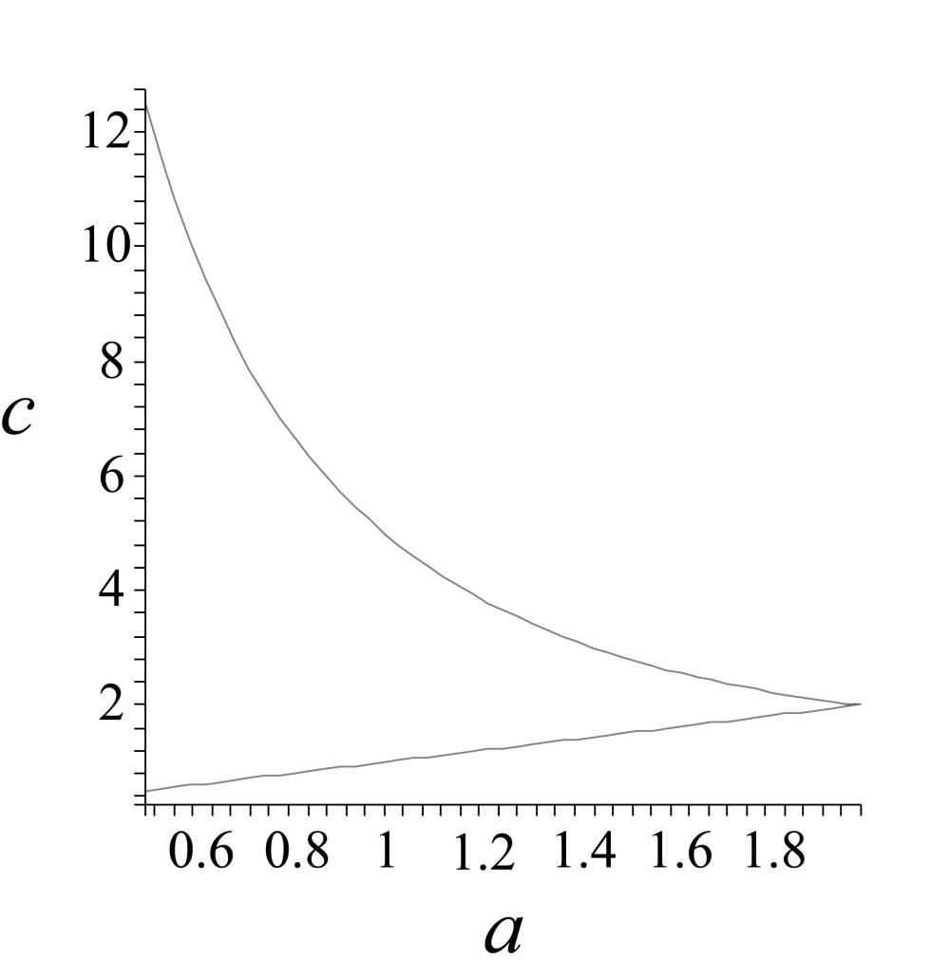
Fig. 1. The graphs of c = a and c = a – 4 + 8/a (from Baesner, Brooks, Radin & Wiandt, 2007, p. 39. Reprinted with permission of the Society for Chaos Theory in Psychology & Life Sciences).
Each figure should occupy a separate page of the manuscript, without the captions, but with all internal lettering and labeling in place. Figures should then be aggregated to the end of the manuscript following tables if any. Figure 1 illustrates a line drawing with caption source credit.
Illustrations should be of professional, camera-ready quality (dark, sharp, and clear), including the labeling. All illustrations must have captions, see above. Symbols and abbreviated units of measure must be explained in the caption. All figures must be prepared for publication in electronic form; the descriptor “camera-ready” is admittedly archaic, but it does convey they we need the figures in final, ready-to-use form. Use a separate file for each figure. The file types .JPG, .GIF, .TIFF, and .PNG are recommended; BITMAP files can be used if they are not too large.
Authors are cautioned against overly-fine detail that is sometimes produced from computer-based media; there is point beyond which the fidelity of reproduction is not guaranteed. Importantly, the size of lettering, such as names on axes of graphs should be large enough relative to the remainder of the image so that the figure can withstand a size reduction. The printed portion of a journal page is 4.5 inches (11.4 cm) wide and 6.75 inches (17.1 cm) high including the caption. Horizontal orientations of the images should be avoided whenever possible. When in doubt, make a print of the image in a size not larger than the specifications above and see how it turns out. Figure 2 is an example of a more complex image that was serviceable, although the type size on the axes of the graph could have been better.
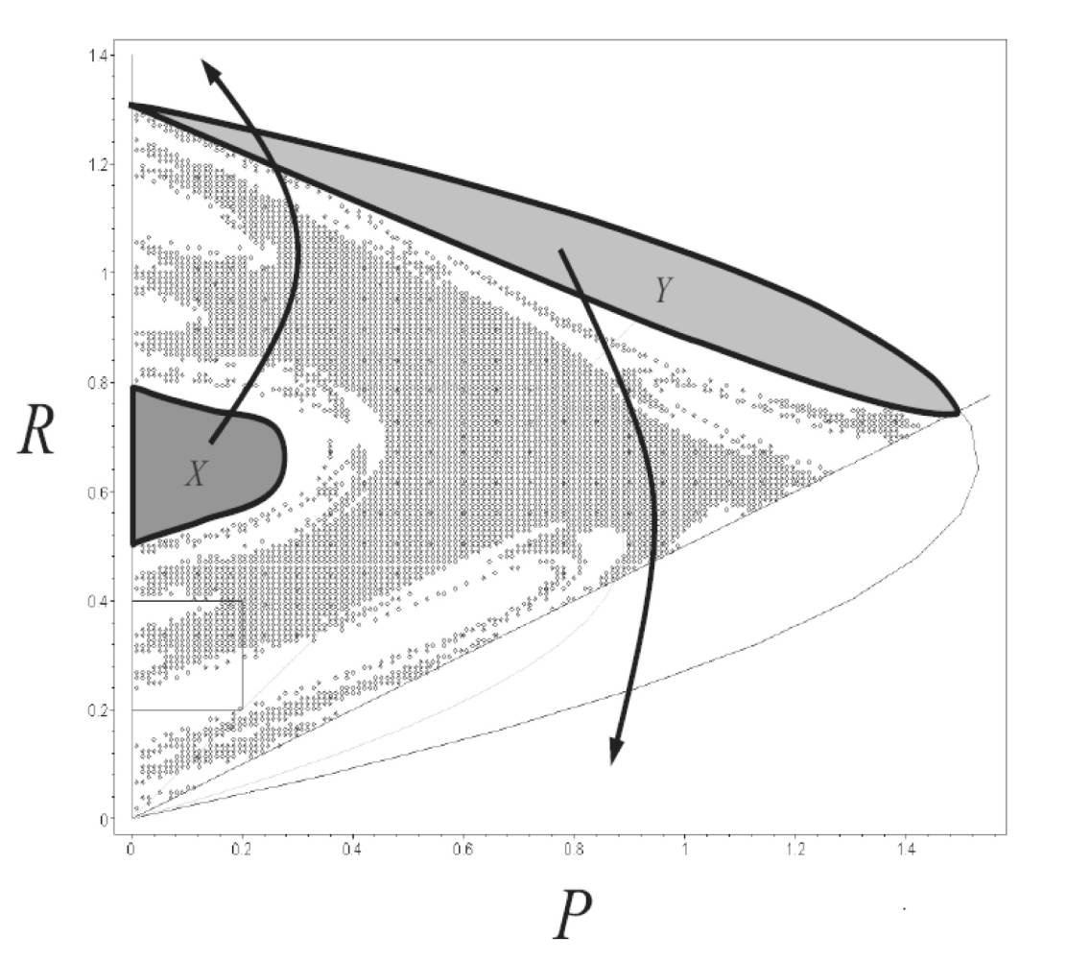
Fig. 2. Example of a more complex image where the line thickness on the axes could have been stronger and darker, and the contrast between the label X and its background could have been stronger as well.
Preparing and Viewing Color Graphics for NDPLS Articles
The NDPLS will, on special occasions, publish articles that contain color figures. The journal will support articles containing color graphics if and only if the color figures convey information that cannot be conveyed in a grayscale production. This provision excludes the use of color or gray-shaded background on line graphs and bar charts; the color in these instances will obscure the real information that the author is trying to convey. The usual requirements for sharpness and clarity apply to the production of color graphics for the journal; in addition, we recommend that color patterns be chosen whenever possible to maximize contrast, especially where fine details are involved.
When preparing review copies of your manuscript, please place hard copies of the color figures in the usual location in the manuscript. When your article is accepted for publication, your color graphics should appear on your final disk in separate files from the main manuscript.
In order to balance the cost of color with the informational advantage of color, the hard copy of NDPLS will contain grayscale versions of the color figures. Hard copy subscribers can view the color figures on the journal’s web site: www.societyforchaostheory.org/ndpls.html. The hard copy of the journal contains an editorial message at the end of each volume year alerting readers to the availability and location of color graphics. Institutions that subscribe to the on-line version of NDPLS will be able to view the color graphics alongside the regular article files.

Mathematical Notation
Authors should provide a key to unusual or complex notion; this goal is usually served by simply defining all variables in the text as soon as they are used for the first time. All variables should be shown in italic type in the manuscript. Boldface type is used only for variables that are specifically vectors or matrices, such as “the trace of the matrix M.” Authors should anticipate that what appears in the manuscript will appear on the printed page. If a variance from this protocol is requested for any reason, please make the request in the cover letter.
Equations may appear in the running text or as display equations that occupy a separate line of type. It is not necessary to number any or all of the display equations, but if the author wishes to refer to an equation later in the text, an equation number is recommended. Only display equations are numbered. Equations are numbered consecutively; decimal systems for equation numbers (which denote numbered sections in other journals) are not used in NDPLS.
Equation boxes are useful for composing display equations that are relatively complex. Please adhere to the following composition requirements for equation boxes.
1. The main type size is 10-point type. Larger characters may be used for brackets and symbols that span two or more lines vertically. Smaller characters may be used for exponents and footnotes. If a complex argument to an exponent is needed, consider the possibility of revising the format of the equation(s) to facilitate larger type on the complex argument for readability. An example would be “exp[arg]” instead of e^{[arg]}.
2. Equation boxes can be no wider than 4 inches (10 cm).
3. Names of variables are italicized Roman or non-italicized Greek characters. Greek characters should be rendered as standard characters in the Symbol font that is available in WORD, and not as boxes containing a single keystroke. Names of vectors or matrices should be rendered in boldface type.
4. It is permissible to use equation boxes in a line of running text if the box contains mathematical symbols that are not available on a standard font or keyboard; see Item 3 above. Do not use equation boxes in running text if they span more than one line vertically. If such an idiom is needed, rephrase the passage to include a display equation instead that can be numbered or not numbered. Idioms such as “dy/dt” should be rendered in horizontal format rather than stacked format. Exponents and subscripts are permissible in running text, however.
When referring to an equation in the text, use the syntax, “... as defined in Eq. 1,” and not “as defined in [1].” If the object of the clause is a set of equations, then write, “as defined in Eqs. 1-3.” If the word “equation” starts the sentence, however, spell out the word, “equation:” “Equations 1-3 define the important...” If a system of two or more equations appears with a single number, refer to it as either “Eqs. 1” or “System 1.”

HUMAN SUBJECTS
For studies utilizing human participants, the treatment of human participants during the study should be in accordance with the ethical standards of the authors’ institutional review board or accepted professional standards of the authors’ countries of origin. It would be helpful if the authors would make such a statement in their cover letter and identify the standards that apply to the research embodied in the manuscript. If the authors in their cover letter identify no such ethical standard, the pertinent standards of the American Psychological Association, or National Institutes of Health (United States) will apply.
In any case, proper treatment of human subjects will be a point of consideration during the manuscript review process. It is understood, furthermore, that the full burden of responsibility for ethical compliance is ultimately on the authors, not the Journal, its Editor, or Publisher.

COPYRIGHTS AND PERMISSIONS
This section of these Instructions details the procedures for giving proper credit in a manuscript to verbal passages, figures, or tables that are reprinted from previously published works. Authors are asked to keep such material to the absolute minimum amounts required to explicate their own ideas. In the relatively rare circumstances where the authors must pay a fee to use a particular piece of material for use in an article for a refereed academic journal such as NDPLS, the fees are to be paid by the author and not the Journal.
To request permission to reprint previously published material, consult the publisher’s web site for pertinent instructions. If instructions are not available from the web site, the acceptable default option is to send two copies of a written letter of request by post to the original publisher’s Permissions Office along with a return envelope. One copy will be signed and returned with permission if granted, or an explanation will be provided. Letters of request should include a description of the material that will be reprinted, (e.g. full citation of the original course, table or figure number in question) and a description of the new work for which it is intended (e.g. an article for NDPLS).
One photocopy of each permission statement must accompany the final accepted version of an NDPLS manuscript. The Contract to Publish will place the full burden of responsibility for obtaining any necessary permissions and identifying proper credit on the author of the manuscript, not the Journal.
Quoted Material
Authors who wish to use verbal quotes (as opposed to figures and tables) from the work of other people may do so under the following conditions. All brief direct quotes must be offset in quotation marks and included as part of the paragraph that is meant to contain the quote. Note the location of the close-quote, citation, use of the page number, and final period in the following example. “Organizational fitness landscapes have been shown to be multi-dimensional with the dimensions being relatively invariant over long time periods” (Haslett & Osborne, 2003, p. 89).
Longer quotes, however, should be set in a separate paragraph with wider margins of 1.5 inches (3 cm.) left and right. The citation information can be placed at the end of the quoted passage as in the previous example or separated as in the following example. Also note the use of ellipses and square brackets to denote a word or type character that is not in the original. According to Stewart (1989):
So ingrained was the linear habit, that by the 1940s and 1950s many scientist[s] and engineers knew little else . . . [W]e live in a world which for centuries acted as if the only animal in existence was the elephant, which assumed that holes in the skirting-board must be made by tiny elephants, which saw the soaring eagle as a wing-eared Dumbo, [and] the tiger as an elephant with a rather short trunk and stripes (p. 83-84).
Note that quotes longer than 99 words can only be reprinted if the author of the manuscript has acquired a signed permission from both the original author and publisher to use the material. It is recommended that if a quote longer than 99 words is relevant to the new manuscript the author should reconsider paraphrasing the source material to the extent that directly quoted material is less than 99 words or not used at all. Citations to such tightly paraphrased material should include the page numbers along with the original authors’ names and publication dates as in the previous example.

Figures and Tables
Authors who wish to reproduce tables and figures from other publications including their own previous works must obtain proper permission to do so as required by the publisher of the original material. Authors may find that they already have such rights to their own material and are not required to obtain permission or pay a fee to the original publisher. Authors who wish to reproduce tables or figures from other publications of which they are not the original authors or co-author must obtain permission from the original publisher and pay any required fees.
A table that is reproduced from another source should be captioned with the table number that pertains to the order of the table in the new manuscript for NDPLS, along with the original table caption. The original table caption is followed by the statement: From [author, date], reproduced by permission from [publisher’s name].
Similarly a figure that is reproduced from another source should be captioned with the figure number that pertains to the order of the figure in the new manuscript for NDPLS, along with either the original caption or a rewritten caption. Either type of caption is followed by the same acknowledgment that is used for tables. This type of acknowledgment is not included in the Acknowledgment section of the manuscript.

Raw Data
Raw data should be regarded as intellectual property in the same manner as finished articles are regarded as intellectual property. If authors are using data that they have collected themselves, they need not be concerned about citing sources for this material.
If authors are using data created by another party, however, clear citations of the data source should be made in the new manuscript. If the data themselves were published somewhere, such as a government or foundation-sponsored archive, the source should be cited. If the data were collected by a private party who published an article or book that was based on the data, those citations should appear in the new manuscript.
Authors should consider carefully whether the originators of the data should be included as authors on the manuscript in preparation. An author should only be included with the explicit agreement of that author. It is understood that university or other institutional rules apply concerning ownership of data sources. The copyright transfer agreement signed by authors when their paper is accepted for publication in NDPLS ensures the Journal that all uses of original data are consistent with any applicable protocols for intellectual properties.

Prior Publication
NDPLS publishes only original scientific works, which means in part that no article published in NDPLS has been published before nor is it being considered simultaneously for publication in another journal while it is being reviewed by NDPLS. It would be extremely helpful if authors would make a clear statement to this effect in their cover letter that accompanies their manuscript submission. In all cases it will be assumed that no such prior publication has occurred and that no simultaneous review for publication is in progress. Manuscripts that are discovered to be too close in content to a prior publication will be considered insufficiently original to warrant publication in NDPLS.
Authors who publish an article in NDPLS and wish to reuse their own material may do so within the limits of the terms and conditions specified in the Permissions and Copyrights section of the NDPLS web site and the Contract to Publish. Those terms and conditions specified in those documents are detailed for both authors of NDPLS articles or other people who wish to use NDPLS material.

OTHER IMPORTANT MATTERS
If any authors encounter an issue with an aspect of manuscript preparation that is not explicitly covered in this document, they should consult the Publication Manual of the American Psychological Association, Fifth Edition (2001). In the event of any discrepancies between the formal APA style and any NDPLS points of style that are clearly defined in this document, the discrepancies should be resolved in favor of the instruction encountered in this document.
If any authors encounter an issue with an aspect of manuscript preparation that is not covered in the Publication Manual or this document they should contact the Editor. Alternatively they are invited to use their best judgment and the Editor will advise on changes if necessary.

ACKNOWLEDGMENT
The Editor wishes to thank the members of the NDPLS Editorial Board and the SCTPLS Publications Committee for their helpful suggestions regarding these Instructions. In normal circumstances, one does not thank the Editor or reviewers.
REFERENCES
Aks, D. J., & Sprott, J. C. (2003). The role of depth and 1/f dynamics in perceiving reversible figures. Nonlinear Dynamics, Psychology, and Life Sciences, 7, 161-180.
American Psychological Association (2001). Publication manual of the American Psychological Association (5th edition). Washington, DC: American Psychological Association.
Baesner W., Brooks, B., Radin, M., & Wiandt, T. (2008). Dynamics of a discrete population model for extinction and sustainability in ancient cultures. Nonlinear Dynamics, Psychology, and Life Sciences, 12, 29-54.
Gregson, R. A. M., Campbell, E. A., & Gates, R. A. (1992). Cognitive load as a determinant of the dimensionality of the electroencephalogram: A replication study. Biological Psychology, 35, 165-178.
Guastello, S. J. (1988). Catastrophe modeling of the accident process: Organizational subunit size. Psychological Bulletin, 103, 246-255.
Harbourne, R. T., Deffeyes, J. E., Kyvelidou, & Stergiou, N. (2009). Complexity of postural control in infants: Linear and nonlinear features revealed by principal components analysis. Nonlinear Dynamics, Psychology, and Life Sciences, 13, 123-144.
Haslett, T., & Osborne, C. (2003). Local rules: Emergence on organizational landscapes. Nonlinear Dynamics, Psychology, and Life Sciences, 7, 87-98.
Kauffman, S. A. (1993). The origins of order: Self-organization and selection in evolution. New York: Oxford University Press.
Kauffman, S. A. (1995). At home in the universe: Self-organization and selection in evolution. New York: Oxford University Press.
Liebovitch, L. S. (2003). Introduction to chaos. Retrieved January 16, 2009 from www.societyforchaostheory.org/tutorials/00002/PPc.ppt.
Marks-Tarlow, T. (1999). The self as a dynamical system. Nonlinear Dynamics, Psychology, and Life Sciences, 3, 311-345.
Mpitsos, G. (2002, August). Attractors: Architects of network organizations. Paper presented to the 12th annual international conference of the Society for Chaos Theory in Psychology & Life Sciences, Portland OR.
Puu, T. (2000). Attractors, bifurcations, and chaos: Nonlinear phenomena in economics. New York: Springer-Verlag.
Sabelli, H. C., Carlson-Sabelli, L., Patel, M., Levy, A., & Diez-Martin, M. (1995). Anger, fear, depression and crime: Physiological and psychological studies using the process method. In R. Robertson & A. Combs (Eds.), Chaos theory in psychology and the life sciences (pp. 65-88). Mahwah, NJ: Lawrence Erlbaum Associates.
Stewart, I. (1989). Does God play dice? The mathematics of chaos. Cambridge, MA: Basil Blackwell.
Wolfram, S. (2002). A new kind of science. Champaign, IL: Wolfram Media.

Correspondence address: [give name, postal address, e-mail. Include telephone and fax numbers in case a production problem arises. Telephone and fax numbers will not appear in print, however.] 1

